**Abhiram Basa**

**Assessment 4 of Data Engineering - 07/12/23**

**Today we executed some joins like inner, left outer join, right outer join and full outer join,functions, aggregate functions.**

**Inner join**

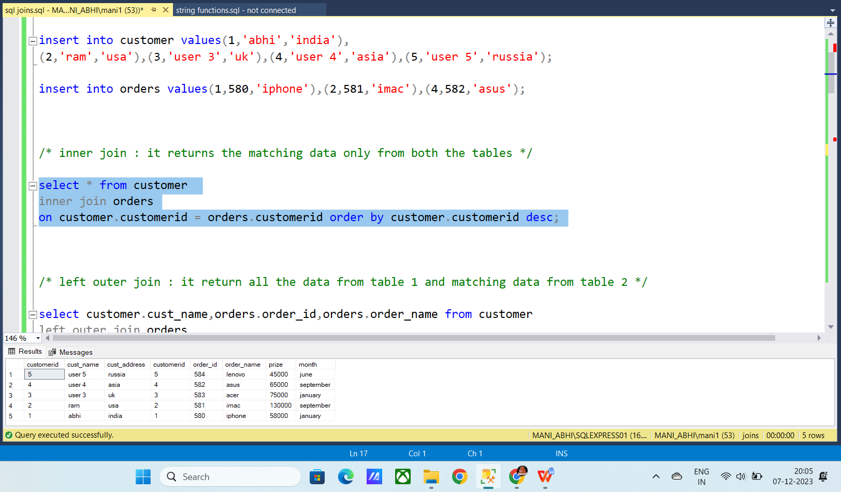

**Left outer join**

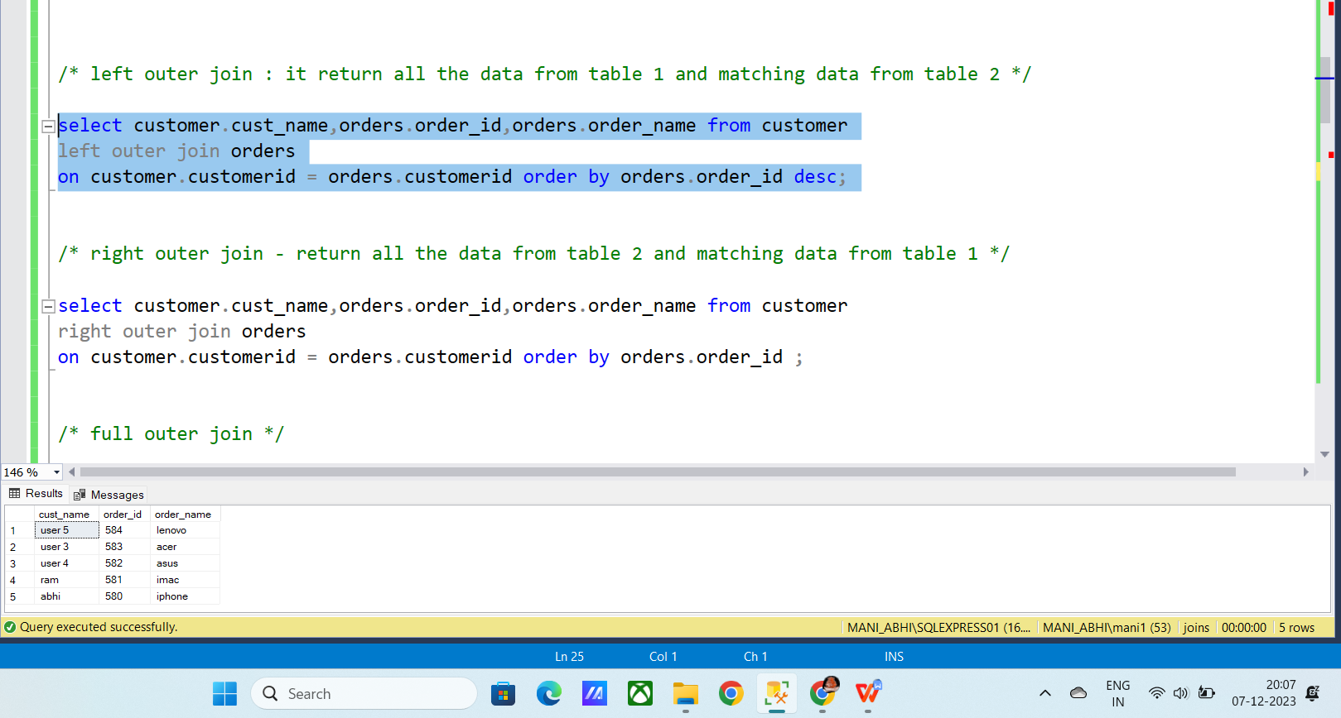

**Right outer join**

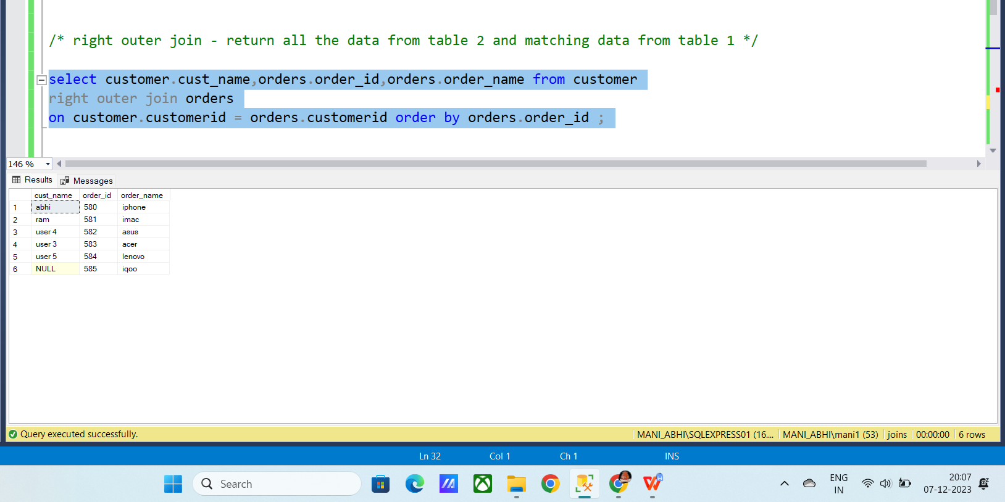

**Full outer join:**

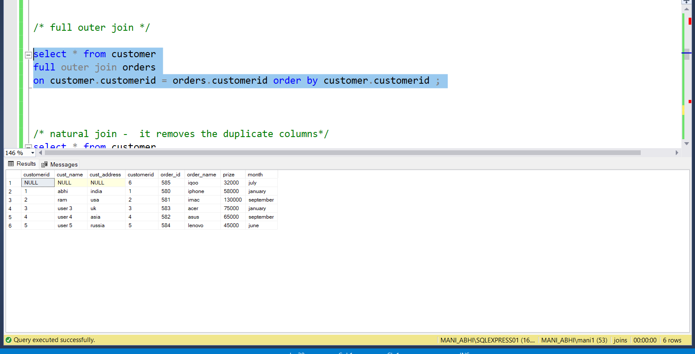

**Stirng functions:**

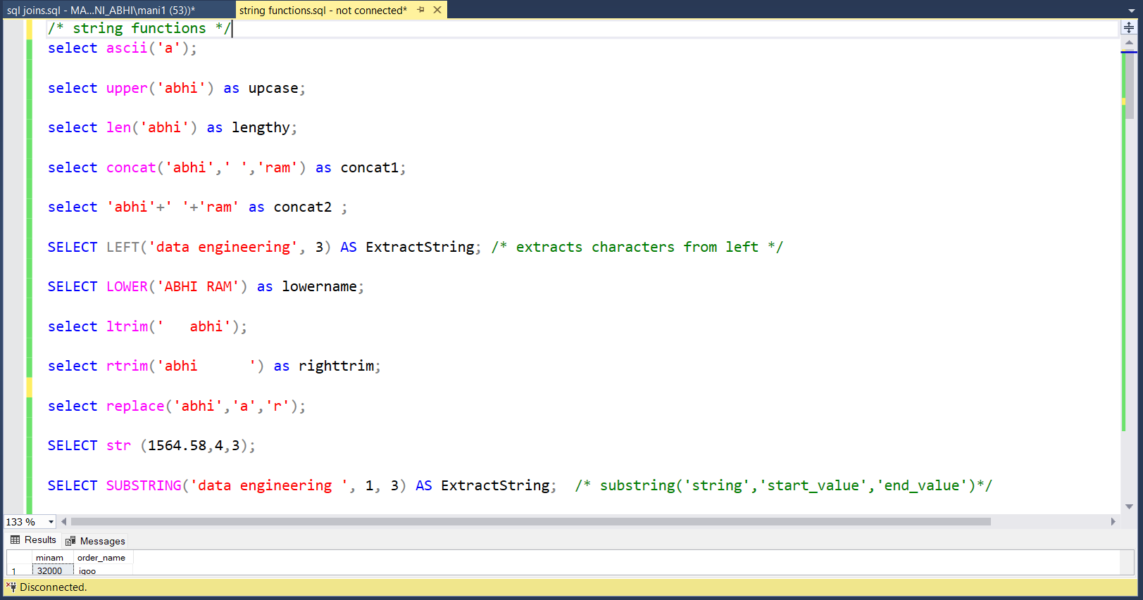

**Date functions :**

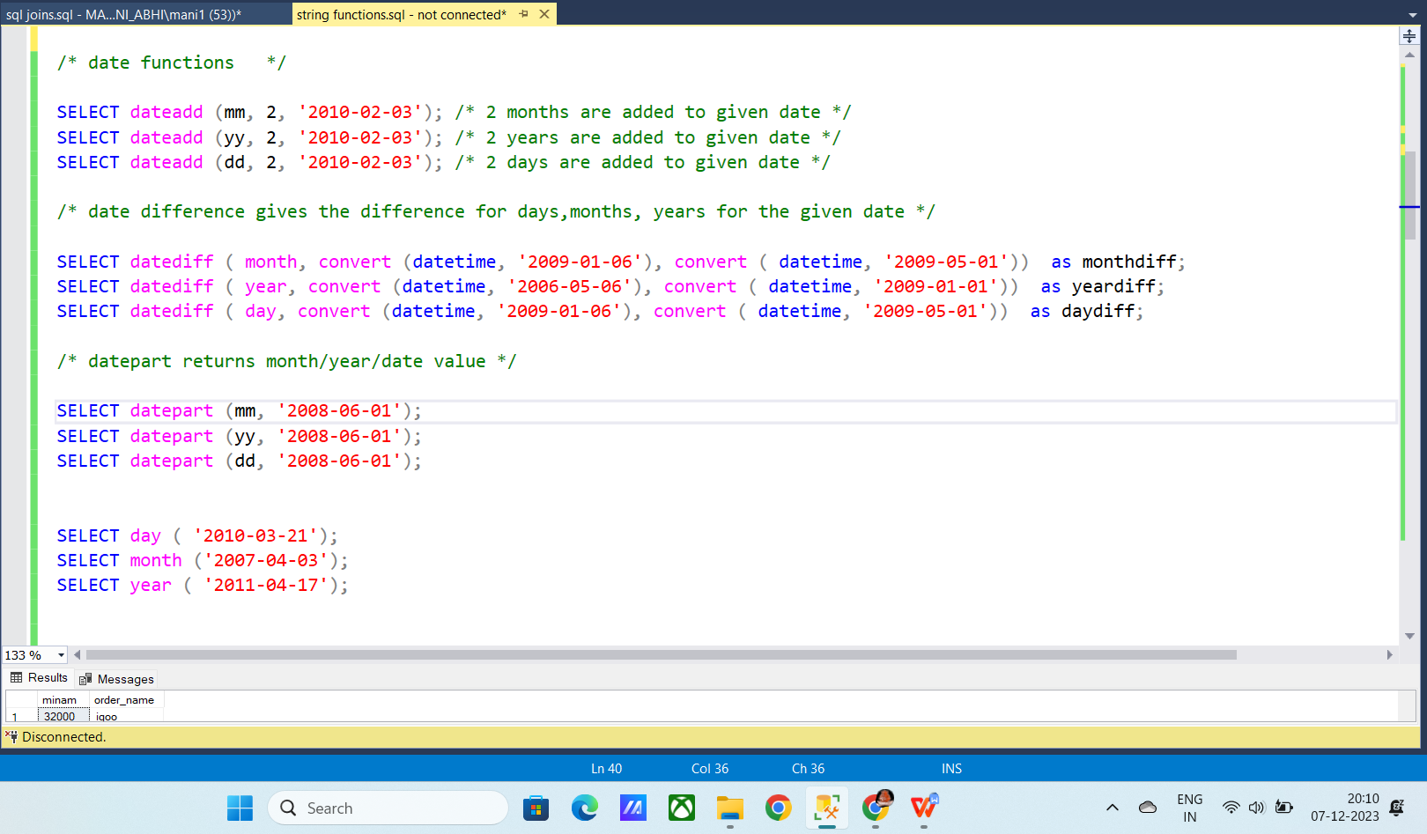

**Math functions;**

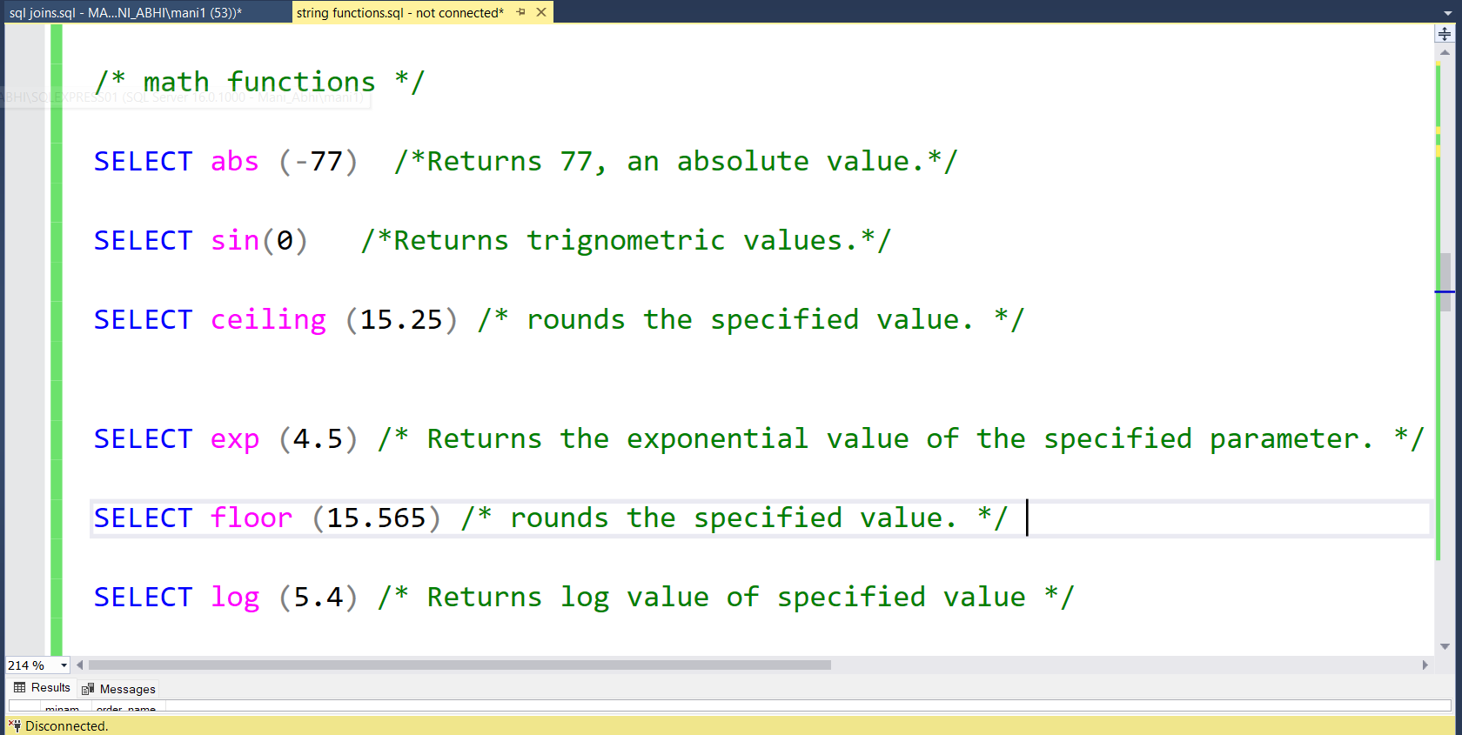

**System functions:**

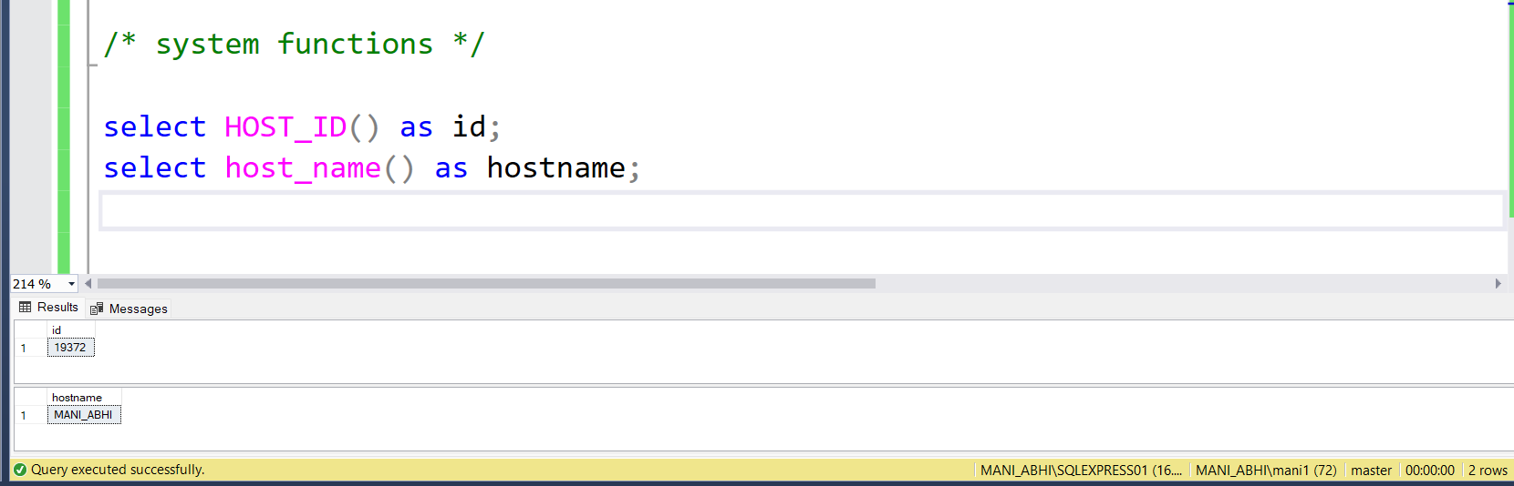

**Ranking functions**

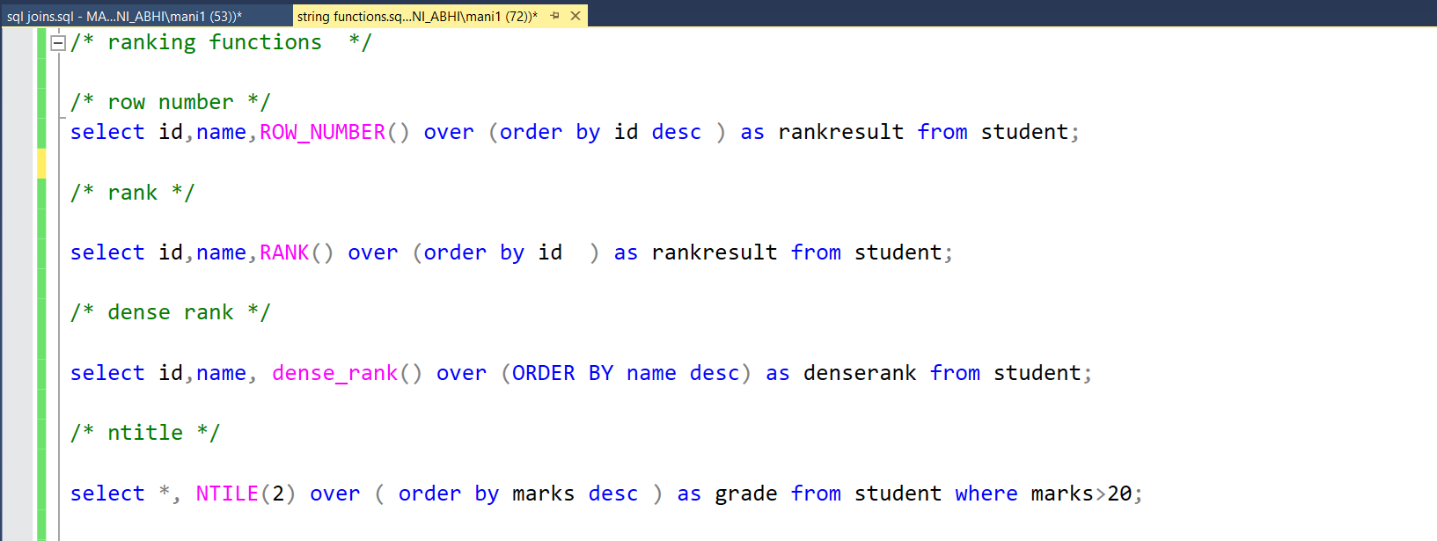

**Aggregations :**

